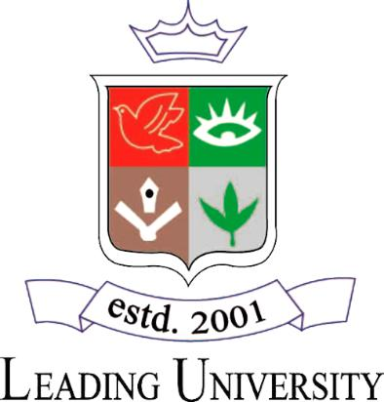

**LEADING UNIVERSITY, SYLHET**

Dept. of Computer Science & Engineering

**An Assignment on**

**Topic**

Course Code: CSE-2214

Course Title: Object Oriented Programming Sessional

**Submitte****d TO**

**Md. Saiful Ambia Chowdhury**

Lecturer

Coach, Programming Contest Teams

Computer Science & Engineering

**Submitted By:**

**Shuvo Goswami**

Student ID: 2012020240

Leading University, Sylhet

**Date Of Submission:** *13/08/2021*

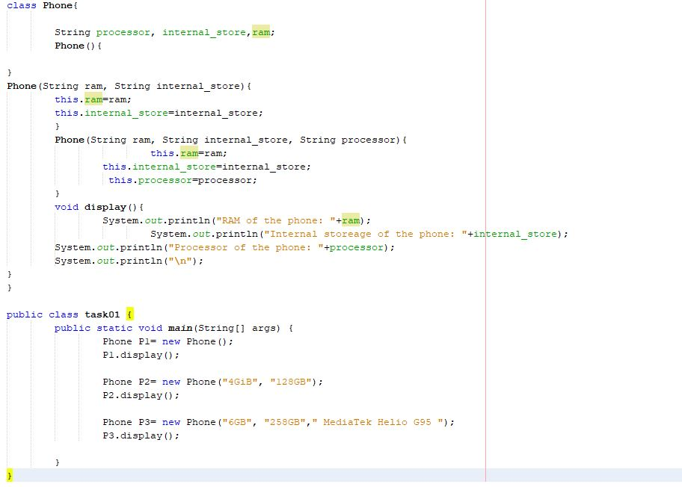

Task1

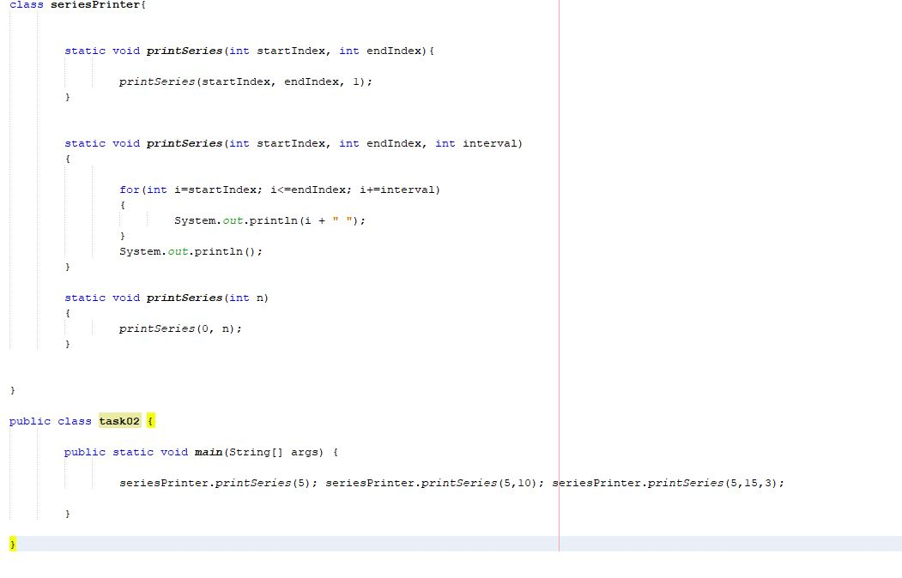

Task 2